**DOCUMENTO DE ESPECIFICACIÓN DE ITERACIONES (SPRINTS) DEL PROYECTO DE IMPLEMENTACIÓN DEL SISTEMA NACIONAL DE INFORMACIÓN DE ANÁLISIS DE RIESGOS DE EXTINCIÓN DE ESPECIES DE FAUNA Y FLORA DE COLOMBIA (SNIARES)**

VERSION 1.0 – 01-12-2016

Elaborado Por: Jaime Alberto Gutiérrez Mejía

# ÍNDICE

ÍNDICE 2

1. PRIMERA ITERACIÓN 3

2. SEGUNDA ITERACIÓN 6

3. TERCERA ITERACIÓN 9

4. CUARTA Y ÚLTIMA ITERACIÓN 13

# PRIMERA ITERACIÓN

|  |  |  |  |  |  |  |  |  |  |  |  |  |  |  |  |  |  |  |  |  |  |  |  |  |  |  |  |  |  |  |
| --- | --- | --- | --- | --- | --- | --- | --- | --- | --- | --- | --- | --- | --- | --- | --- | --- | --- | --- | --- | --- | --- | --- | --- | --- | --- | --- | --- | --- | --- | --- |
|  |  |  |  |  |  |  |  |  |  |  |  |  |  |  |  |  |  |  |  |  |  |  |  |  |  |  |  |  |  |  |
|  |  |  |  |  |  |  |  |  |  |  |  |  |  |  |  |  |  |  |  |  |  |  |  |  |  |  |  |  |  |  |
|  |  | SPRINT | INICIO | DURACIÓN |  |  |  |  |  |  |  |  |  |  |  |  |  |  |  |  |  |  |  |  |  |  |  |  |  |  |
|  |  | 1 | 17-oct.-16 | 17 |  |  | L | M | X | J | V | L | M | X | J | V | L | M | X | J | V | M |  |  |  |  |  |  |  |  |
|  |  |  |  |  |  |  | ##### | ##### | ##### | ##### | ##### | ##### | ##### | ##### | ##### | ##### | ##### | 1-nov. | 2-nov. | 3-nov. | 4-nov. | 8-nov. |  |  |  |  |  |  |  |  |
|  |  |  |  | Tareas pendientes | | | 1 | 1 | 1 | 2 | 2 | 1 | 1 | 1 | 1 | 1 | 1 | 2 | 1 | 1 | 2 | 1 |  |  |  |  |  |  |  |  |
|  |  |  |  | Horas de trabajo pendientes | | | 3 | 4 | 8 | 12 | 12 | 5 | 3 | 5 | 4 | 4 | 4 | 8 | 2 | 3 | 4 | 4 |  |  |  |  |  |  |  |  |
| **PILA DEL SPRINT** | | | | | | | **ESFUERZO** | | | | | | | | | | | | | | | | | | | | | | | |
| **Backlog ID** | **Tarea** | | | **Tipo** | **Estado** | **Responsable** |
| 1 | Reunión de Inicio del Proyecto | | | Reunión | Terminada | Carolina Castellanos | 3 |  |  |  |  |  |  |  |  |  |  |  |  |  |  |  |  |  |  |  |  |  |  |  |
| 2 | Revisión de la estructura del GITHUB | | | Análisis | Terminada | Jaime Gutiérrez |  | 4 |  |  |  |  |  |  |  |  |  |  |  |  |  |  |  |  |  |  |  |  |  |  |
| 3 | Descarga de Software para las pruebas | | | Tarea operativa | Terminada | Jaime Gutiérrez |  |  | 8 | 2 |  |  |  |  |  |  |  |  |  |  |  |  |  |  |  |  |  |  |  |  |
| 4 | Configuración del entorno de línea base | | | Prueba | Terminada | Jaime Gutiérrez |  |  |  | 10 | 10 |  |  |  |  |  |  |  |  |  |  |  |  |  |  |  |  |  |  |  |
| 5 | Desarrollo de la integración y paquetes | | | Prueba | Terminada | Jaime Gutiérrez |  |  |  |  | 2 | 5 |  |  |  |  |  |  |  |  |  |  |  |  |  |  |  |  |  |  |
| 6 | Reunión de Revisión de Estado | | | Reunión | Terminada | Ricardo Reyes |  |  |  |  |  |  | 3 |  |  |  |  |  |  |  |  |  |  |  |  |  |  |  |  |  |
| 7 | Prueba en entorno local | | | Prueba | Terminada | Ricardo Reyes |  |  |  |  |  |  |  | 5 |  |  |  |  |  |  |  |  |  |  |  |  |  |  |  |  |
| 8 | Configuración del vagrant | | | Tarea operativa | Terminada | Jaime Gutiérrez |  |  |  |  |  |  |  |  | 4 | 4 |  |  |  |  |  |  |  |  |  |  |  |  |  |  |
| 9 | Despliegue del ambiente OVM | | | Tarea operativa | Terminada | Jaime Gutiérrez |  |  |  |  |  |  |  |  |  |  | 4 | 3 |  |  |  |  |  |  |  |  |  |  |  |  |
| 10 | Instalación de la Máquina Virtual | | | Despliegue | Terminada | Jaime Gutiérrez |  |  |  |  |  |  |  |  |  |  |  | 5 | 2 | 3 | 2 |  |  |  |  |  |  |  |  |  |
| 11 | Reporte inicial de resultados | | | Reporte | Terminada | Jaime Gutiérrez |  |  |  |  |  |  |  |  |  |  |  |  |  |  | 2 |  |  |  |  |  |  |  |  |  |
| 12 | Revisión y seguimiento de proyecto | | | Reporte | Terminada | Ricardo Reyes |  |  |  |  |  |  |  |  |  |  |  |  |  |  |  | 4 |  |  |  |  |  |  |  |  |

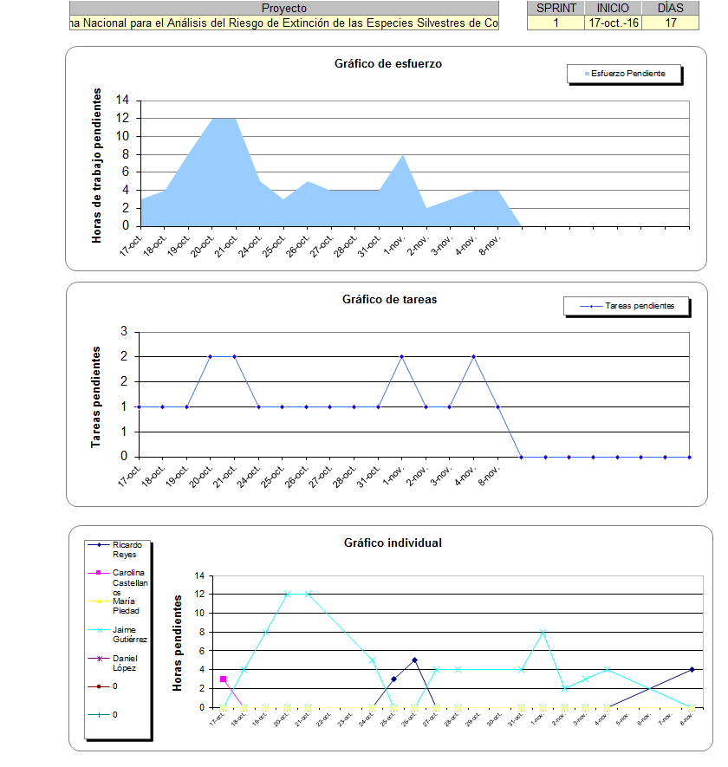

# SEGUNDA ITERACIÓN

|  |  |  |  |  |  |  |  |  |  |  |  |  |  |  |  |  |  |  |  |  |  |  |  |  |  |  |  |  |  |  |
| --- | --- | --- | --- | --- | --- | --- | --- | --- | --- | --- | --- | --- | --- | --- | --- | --- | --- | --- | --- | --- | --- | --- | --- | --- | --- | --- | --- | --- | --- | --- |
|  |  |  |  |  |  |  |  |  |  |  |  |  |  |  |  |  |  |  |  |  |  |  |  |  |  |  |  |  |  |  |
|  |  |  |  |  |  |  |  |  |  |  |  |  |  |  |  |  |  |  |  |  |  |  |  |  |  |  |  |  |  |  |
|  |  | SPRINT | INICIO | DURACIÓN |  |  |  |  |  |  |  |  |  |  |  |  |  |  |  |  |  |  |  |  |  |  |  |  |  |  |
|  |  | 2 | 10-nov.-16 | 9 |  |  | J | V | M | X | J | V | L | M |  |  |  |  |  |  |  |  |  |  |  |  |  |  |  |  |
|  |  |  |  |  |  |  | ##### | ##### | ##### | ##### | ##### | ##### | ##### | ##### |  |  |  |  |  |  |  |  |  |  |  |  |  |  |  |  |
|  |  |  |  | Tareas pendientes | | | 1 | 1 | 1 | 3 | 4 | 7 | 6 | 5 | 4 |  |  |  |  |  |  |  |  |  |  |  |  |  |  |  |
|  |  |  |  | Horas de trabajo pendientes | | | 4 | 3 | 6 | 18 | 22 | 18 | 30 | 34 | 22 |  |  |  |  |  |  |  |  |  |  |  |  |  |  |  |
| **PILA DEL SPRINT** | | | | | | | **ESFUERZO** | | | | | | | | | | | | | | | | | | | | | | | |
| **Backlog ID** | **Tarea** | | | **Tipo** | **Estado** | **Responsable** |
| t | Instalación del ambiente en portátil Humboldt | | | Despliegue | Terminada | Jaime Gutiérrez | 4 |  |  |  |  |  |  |  |  |  |  |  |  |  |  |  |  |  |  |  |  |  |  |  |
| 2 | Reporte de Instalación y seguimiento a la supervisión | | | Reporte | Terminada | Jaime Gutiérrez |  | 3 |  |  |  |  |  |  |  |  |  |  |  |  |  |  |  |  |  |  |  |  |  |  |
| 3 | Revisión inicial de casos de uso | | | Reunión | Terminada | Carolina Castellanos |  |  | 6 | 2 | 3 |  |  |  |  |  |  |  |  |  |  |  |  |  |  |  |  |  |  |  |
| 4 | Reuniones de seguimiento técnico con CNCFLORA BRASIL | | | Reunión | Terminada | Ricardo Reyes |  |  |  |  |  | 2 |  |  |  |  |  |  |  |  |  |  |  |  |  |  |  |  |  |  |
| 5 | Retroalimentación de usuarios funcionales | | | Análisis | Terminada | Jaime Gutiérrez |  |  |  |  |  |  | 5 | 2 |  |  |  |  |  |  |  |  |  |  |  |  |  |  |  |  |
| 6 | Ajuste del ambiente de Portal | | | Tarea operativa | Terminada | Jaime Gutiérrez |  |  |  | 8 | 8 | 2 | 4 |  |  |  |  |  |  |  |  |  |  |  |  |  |  |  |  |  |
| 7 | Traducción de textos del portugues al español | | | Tarea operativa | Terminada | Jaime Gutiérrez |  |  |  |  | 5 | 2 |  |  |  |  |  |  |  |  |  |  |  |  |  |  |  |  |  |  |
| 8 | Análisis de la base de datos COUCHDB | | | Análisis | Terminada | Jaime Gutiérrez |  |  |  | 8 | 6 | 2 | 5 |  |  |  |  |  |  |  |  |  |  |  |  |  |  |  |  |  |
| 9 | Análisis del manejador de índices ELASTICSEARCH | | | Análisis | Terminada | Jaime Gutiérrez |  |  |  |  |  | 3 | 5 |  |  |  |  |  |  |  |  |  |  |  |  |  |  |  |  |  |
| 10 | Reunión de revisión con CNCFLORA BRASIL | | | Reunión | Terminada | Ricardo Reyes |  |  |  |  |  |  |  | 4 |  |  |  |  |  |  |  |  |  |  |  |  |  |  |  |  |
| 11 | Ajuste de ambiente NUVEM CLUSTER APPS | | | Tarea operativa | Terminada | Jaime Gutiérrez |  |  |  |  |  |  |  | 4 | 2 |  |  |  |  |  |  |  |  |  |  |  |  |  |  |  |
| 12 | Configuración del problema de BAD GATEWAY 502 | | | Tarea operativa | Terminada | Jaime Gutiérrez |  |  |  |  |  |  |  | 4 | 2 |  |  |  |  |  |  |  |  |  |  |  |  |  |  |  |
| 13 | Reporte de Estado del Proyecto a la supervisión | | | Reporte | Terminada | Jaime Gutiérrez |  |  |  |  |  |  |  |  | 3 |  |  |  |  |  |  |  |  |  |  |  |  |  |  |  |
| 14 | Observaciones del equipo funcional | | | Análisis | Terminada | María Piedad |  |  |  |  |  | 2 | 1 |  |  |  |  |  |  |  |  |  |  |  |  |  |  |  |  |  |
| 15 | Mejoras en el rendimiento | | | Tarea operativa | Terminada | Jaime Gutiérrez |  |  |  |  |  | 5 | 10 | 20 |  |  |  |  |  |  |  |  |  |  |  |  |  |  |  |  |
| 16 | Desarrollo de pruebas de cargue | | | Prueba | Terminada | Jaime Gutiérrez |  |  |  |  |  |  |  |  | 15 |  |  |  |  |  |  |  |  |  |  |  |  |  |  |  |

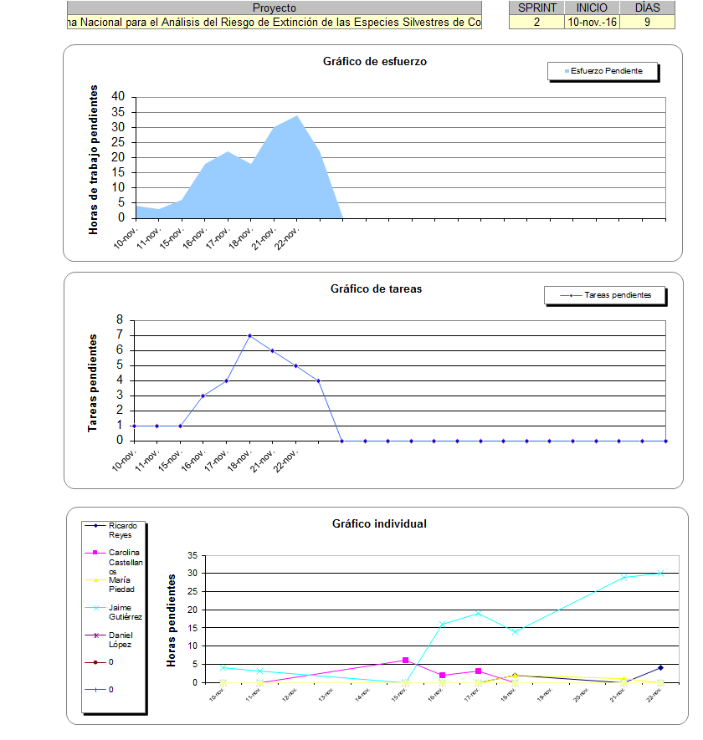

# TERCERA ITERACIÓN

|  |  |  |  |  |  |  |  |  |  |  |  |  |  |  |  |  |  |  |  |  |  |  |  |  |  |  |  |  |  |  |
| --- | --- | --- | --- | --- | --- | --- | --- | --- | --- | --- | --- | --- | --- | --- | --- | --- | --- | --- | --- | --- | --- | --- | --- | --- | --- | --- | --- | --- | --- | --- |
|  |  |  |  |  |  |  |  |  |  |  |  |  |  |  |  |  |  |  |  |  |  |  |  |  |  |  |  |  |  |  |
|  |  |  |  |  |  |  |  |  |  |  |  |  |  |  |  |  |  |  |  |  |  |  |  |  |  |  |  |  |  |  |
|  |  | SPRINT | INICIO | DURACIÓN |  |  |  |  |  |  |  |  |  |  |  |  |  |  |  |  |  |  |  |  |  |  |  |  |  |  |
|  |  | 3 | 25-nov.-16 | 10 |  |  | V | L | M | X | J | V | L | M | X | V |  |  |  |  |  |  |  |  |  |  |  |  |  |  |
|  |  |  |  |  |  |  | ##### | ##### | ##### | ##### | 1-dic. | 2-dic. | 5-dic. | 6-dic. | 7-dic. | 9-dic. |  |  |  |  |  |  |  |  |  |  |  |  |  |  |
|  |  |  |  | Tareas pendientes | | | 1 | 3 | 2 | 3 | 1 | 3 | 3 | 2 | 1 | 1 |  |  |  |  |  |  |  |  |  |  |  |  |  |  |
|  |  |  |  | Horas de trabajo pendientes | | | 5 | 10 | 15 | 10 | 10 | 11 | 5 | 8 | 25 | 4 |  |  |  |  |  |  |  |  |  |  |  |  |  |  |
| **PILA DEL SPRINT** | | | | | | | **ESFUERZO** | | | | | | | | | | | | | | | | | | | | | | | |
| **Backlog ID** | **Tarea** | | | **Tipo** | **Estado** | **Responsable** |
| 1 | Desarrollo de la automatización del cargue | | | Despliegue | Terminada | Jaime Gutiérrez | 5 |  |  |  |  |  |  |  |  |  |  |  |  |  |  |  |  |  |  |  |  |  |  |  |
| 2 | Reporte a la supervisión del contrato | | | Reporte | Terminada | Jaime Gutiérrez |  | 2 |  |  |  |  |  |  |  |  |  |  |  |  |  |  |  |  |  |  |  |  |  |  |
| 3 | Pruebas de cargue masivo en COUCHDB | | | Reunión | Terminada | Jaime Gutiérrez |  | 3 | 5 |  |  |  |  |  |  |  |  |  |  |  |  |  |  |  |  |  |  |  |  |  |
| 4 | Pruebas de cargue masivo de índice en ELASTICSEARCH | | | Reunión | Terminada | Jaime Gutiérrez |  | 5 | 10 |  |  |  |  |  |  |  |  |  |  |  |  |  |  |  |  |  |  |  |  |  |
| 5 | Despliegue del ambiente inicial con las traducciones | | | Análisis | Terminada | Jaime Gutiérrez |  |  |  | 2 |  |  |  |  |  |  |  |  |  |  |  |  |  |  |  |  |  |  |  |  |
| 6 | Remisión del repositorio de textos e imágenes | | | Tarea operativa | Terminada | Carolina Castellanos |  |  |  | 4 |  |  |  |  |  |  |  |  |  |  |  |  |  |  |  |  |  |  |  |  |
| 7 | Remisión del repositorio de libros de especies amenazadas | | | Tarea operativa | Terminada | María Piedad |  |  |  | 4 |  |  |  |  |  |  |  |  |  |  |  |  |  |  |  |  |  |  |  |  |
| 8 | Organización del contenido para cargue en el Sistema Web | | | Análisis | Terminada | Jaime Gutiérrez |  |  |  |  | 10 |  |  |  |  |  |  |  |  |  |  |  |  |  |  |  |  |  |  |  |
| 9 | Realización de pruebas de validación | | | Análisis | Terminada | Jaime Gutiérrez |  |  |  |  |  | 5 |  |  |  |  |  |  |  |  |  |  |  |  |  |  |  |  |  |  |
| 10 | Configuración de roles y usuarios de entrypoint | | | Reunión | Terminada | Jaime Gutiérrez |  |  |  |  |  | 4 | 2 |  |  |  |  |  |  |  |  |  |  |  |  |  |  |  |  |  |
| 11 | Prueba de los Servicios Web de CNCFLORA DATA | | | Tarea operativa | Terminada | Ricardo Reyes |  |  |  |  |  | 2 | 1 |  |  |  |  |  |  |  |  |  |  |  |  |  |  |  |  |  |
| 12 | Remisión del reporte de estado del proyecto | | | Tarea operativa | Terminada | Jaime Gutiérrez |  |  |  |  |  |  | 2 |  |  |  |  |  |  |  |  |  |  |  |  |  |  |  |  |  |
| 13 | Pruebas de verificación del cargue de especies | | | Reporte | Terminada | Jaime Gutiérrez |  |  |  |  |  |  |  | 4 |  |  |  |  |  |  |  |  |  |  |  |  |  |  |  |  |
| 14 | Validación del contenido de las especies | | | Análisis | Terminada | Ricardo Reyes |  |  |  |  |  |  |  | 4 |  |  |  |  |  |  |  |  |  |  |  |  |  |  |  |  |
| 15 | Ajustes de la imagen visual del aplicativo | | | Tarea operativa | Terminada | Jaime Gutiérrez |  |  |  |  |  |  |  |  | 25 |  |  |  |  |  |  |  |  |  |  |  |  |  |  |  |
| 16 | Reunión de Revisión y Seguimiento | | | Prueba | Terminada | Carolina Castellanos |  |  |  |  |  |  |  |  |  | 4 |  |  |  |  |  |  |  |  |  |  |  |  |  |  |

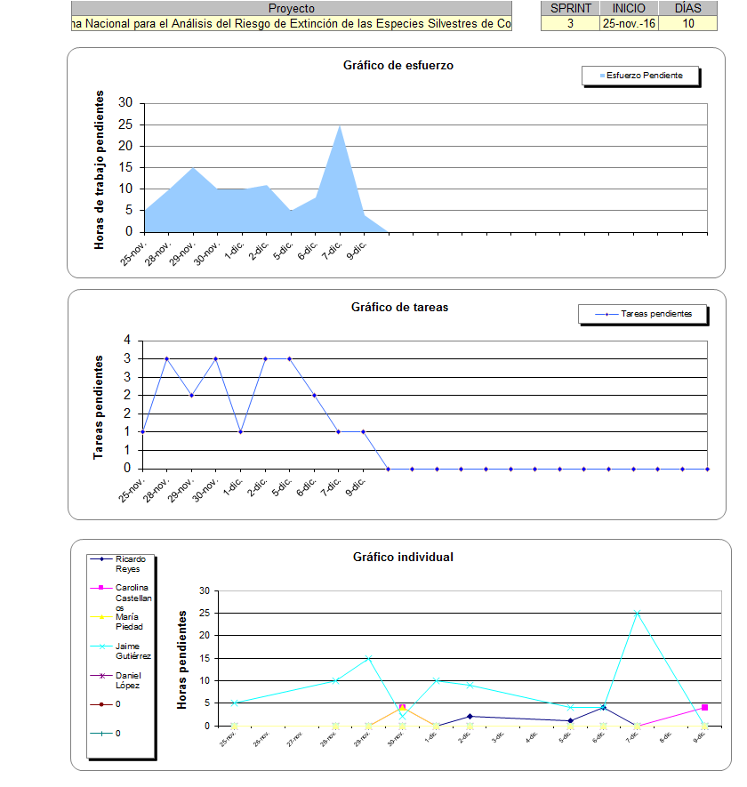

# CUARTA Y ÚLTIMA ITERACIÓN

|  |  |  |  |  |  |  |  |  |  |  |  |  |  |  |  |  |  |  |  |  |  |  |  |  |  |  |  |  |  |  |
| --- | --- | --- | --- | --- | --- | --- | --- | --- | --- | --- | --- | --- | --- | --- | --- | --- | --- | --- | --- | --- | --- | --- | --- | --- | --- | --- | --- | --- | --- | --- |
|  |  |  |  |  |  |  |  |  |  |  |  |  |  |  |  |  |  |  |  |  |  |  |  |  |  |  |  |  |  |  |
|  |  |  |  |  |  |  |  |  |  |  |  |  |  |  |  |  |  |  |  |  |  |  |  |  |  |  |  |  |  |  |
|  |  | SPRINT | INICIO | DURACIÓN |  |  |  |  |  |  |  |  |  |  |  |  |  |  |  |  |  |  |  |  |  |  |  |  |  |  |
|  |  | 4 | 10-dic.-16 | 6 |  |  | S | L | M | X | J | V | L |  |  |  |  |  |  |  |  |  |  |  |  |  |  |  |  |  |
|  |  |  |  |  |  |  | 10-dic. | 12-dic. | 13-dic. | 14-dic. | 15-dic. | 16-dic. | 19-dic. |  |  |  |  |  |  |  |  |  |  |  |  |  |  |  |  |  |
|  |  |  |  | Tareas pendientes | | | 1 | 1 | 1 | 4 | 2 | 2 | 5 |  |  |  |  |  |  |  |  |  |  |  |  |  |  |  |  |  |
|  |  |  |  | Horas de trabajo pendientes | | | 8 | 5 | 4 | 12 | 15 | 16 | 21 |  |  |  |  |  |  |  |  |  |  |  |  |  |  |  |  |  |
| **PILA DEL SPRINT** | | | | | | | **ESFUERZO** | | | | | | | | | | | | | | | | | | | | | | | |
| **Backlog ID** | **Tarea** | | | **Tipo** | **Estado** | **Responsable** |
| 1 | Traducción de textos finales | | | Tarea operativa | Terminada | Jaime Gutiérrez | 8 |  |  |  |  |  |  |  |  |  |  |  |  |  |  |  |  |  |  |  |  |  |  |  |
| 2 | Incorporación de WebServices REST para prueba BIOMODELOS | | | Desarrollo | Terminada | Jaime Gutiérrez |  | 5 |  |  |  |  |  |  |  |  |  |  |  |  |  |  |  |  |  |  |  |  |  |  |
| 3 | Configuración de Apache para despliegue de WS REST | | | Despliegue | Terminada | Jaime Gutiérrez |  |  | 4 |  |  |  |  |  |  |  |  |  |  |  |  |  |  |  |  |  |  |  |  |  |
| 4 | Ajuste y parametrización | | | Despliegue | Terminada | Jaime Gutiérrez |  |  |  | 2 |  |  |  |  |  |  |  |  |  |  |  |  |  |  |  |  |  |  |  |  |
| 5 | Elaboración de la documentación técnica | | | Documentación | Terminada | Jaime Gutiérrez |  |  |  | 6 |  |  |  |  |  |  |  |  |  |  |  |  |  |  |  |  |  |  |  |  |
| 6 | Actualización de manuales | | | Documentación | Terminada | Jaime Gutiérrez |  |  |  | 2 |  |  |  |  |  |  |  |  |  |  |  |  |  |  |  |  |  |  |  |  |
| 7 | Entrega del listado de especies | | | Tarea operativa | Terminada | Carolina Castellanos |  |  |  | 2 |  |  |  |  |  |  |  |  |  |  |  |  |  |  |  |  |  |  |  |  |
| 8 | Ejecución del cliente de migración | | | Tarea operativa | Terminada | Jaime Gutiérrez |  |  |  |  | 5 |  |  |  |  |  |  |  |  |  |  |  |  |  |  |  |  |  |  |  |
| 9 | Cargue de especies en el ambiente preproductivo | | | Tarea operativa | Terminada | Jaime Gutiérrez |  |  |  |  | 10 |  |  |  |  |  |  |  |  |  |  |  |  |  |  |  |  |  |  |  |
| 10 | Instalación del ambiente de pruebas en Portátil | | | Despliegue | Terminada | Jaime Gutiérrez |  |  |  |  |  | 8 |  |  |  |  |  |  |  |  |  |  |  |  |  |  |  |  |  |  |
| 11 | Configuración del ambiente preproductivo en servidor de aprovisionamiento de Datacenter | | | Despliegue | Terminada | Jaime Gutiérrez |  |  |  |  |  | 8 |  |  |  |  |  |  |  |  |  |  |  |  |  |  |  |  |  |  |
| 12 | Tareas de validación | | | Tarea operativa | Terminada | Ricardo Reyes |  |  |  |  |  |  | 2 |  |  |  |  |  |  |  |  |  |  |  |  |  |  |  |  |  |
| 13 | Organización de la documentación | | | Documentación | Terminada | Jaime Gutiérrez |  |  |  |  |  |  | 5 |  |  |  |  |  |  |  |  |  |  |  |  |  |  |  |  |  |
| 14 | Entrega de la carpeta de entregables | | | Tarea operativa | Terminada | Jaime Gutiérrez |  |  |  |  |  |  | 10 |  |  |  |  |  |  |  |  |  |  |  |  |  |  |  |  |  |
| 15 | Revisión de ajustes con la supervisión | | | Despliegue | Terminada | Ricardo Reyes |  |  |  |  |  |  | 2 |  |  |  |  |  |  |  |  |  |  |  |  |  |  |  |  |  |
| 16 | Optimizaciones y mejora para la entrega | | | Tarea operativa | Terminada | Jaime Gutiérrez |  |  |  |  |  |  | 2 |  |  |  |  |  |  |  |  |  |  |  |  |  |  |  |  |  |

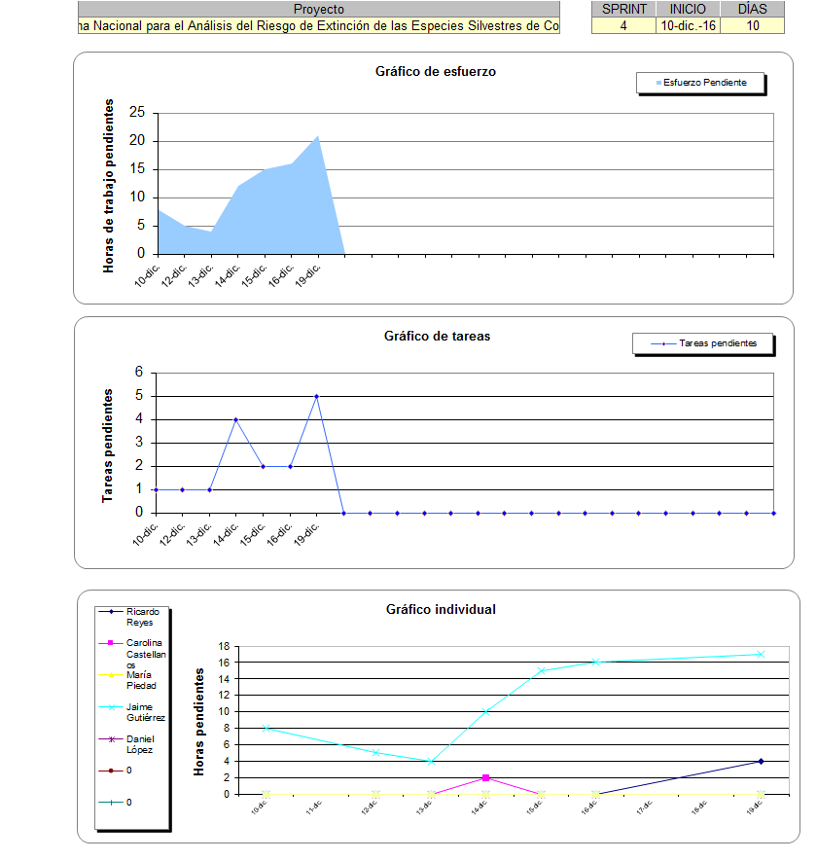

**ELABORÓ: INGENIERO JAIME ALBERTO GUTIÉRREZ MEJÍA**

**CONTRATISTA INSTITUTO ALEXANDER VON HUMBOLDT**